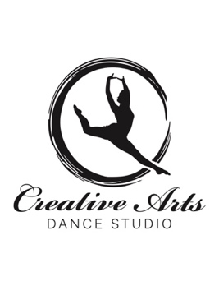

Welcome parents and students to the 2024/2025 dance season! We are excited to start this season with new and returning students. Classes start **Monday, September 16th.**

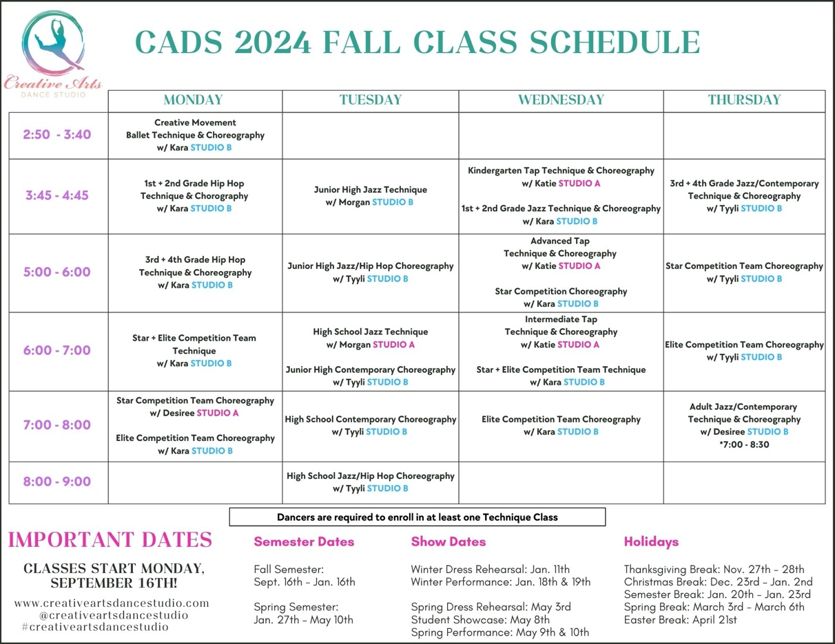

**Tuition, Registration and Fees**

**Registration**: Receipt of a completed registration packet including registration form, hold harmless, permission slip, photo release, $10 registration fee, tuition, costume fee and membership to the Creative Arts Center is required to enroll in class.

**Tuition**: We accept credit cards, checks and cash. Tuition covers class fees and dress rehearsals. Option to pay auto monthly or monthly manual. An invoice will be sent to your email should you choose monthly manual.

**Tuition Due**: Payments are due the 15th of each month. Please check your email as invoices will be sent out two weeks before the due date. Please note, students are unable to participate in class if tuition is not paid in full.

**Communications**: Please download the Band App. Band is an easy to use, free, downloadable app that makes scheduling and updating easy. It has a posting platform allowing teachers to easily send a note to the whole class as well as chat privately with dancers/parents. Band Link > <https://band.us/nc/bbodE8c9A3yeN>

**No Refunds or Credits** are allowed for missed classes. Talk to your instructor about making up missed classes.

**Cancellation:** We reserve the right to cancel class or classes with low attendance and to substitute an instructor at our discretion. Make-up classes will be scheduled.

**Attendance**: Active participation and attendance is essential in any team sport! If your dancer intends to miss class, please send your instructor a note on band. Also, please do not drop off/pick up your child more than 15 minutes before/after their class time. Instructors use their extra time at the studio to prep!

**Withdrawals**: Please notify us in advance if your child is withdrawing. If we are not notified you will be billed for that month whether your child is in attendance or not.

**Fundraiser Money**: Fundraising credit will be applied to your invoice the month following the fundraiser.

**Scholarships:** CADS believe finances should not come in the way of your child’s passion. Therefore, the *Stevie Anne Sorenson* *Scholarship* is a wonderful way to ease financial stress. Every year dancers are awarded full or half year scholarships. Please request an application if interested. In addition, the Creative Arts Center has created the CAC Program Scholarship. This scholarship is also available for CADS dancers.

**Costume Fee:** Costume fees will be determined by the number of choreography classes a student is enrolled in. This fee will be due at registration. Costumes are ordered in the fall and spring. Costume fee includes 1 pair of performance tights. If you are unable to participate in either recital, please notify your instructor prior to costume orders. Please note, dancers must enroll in a technique class in order to perform in a choreography class.

**Costume Fee Breakdown:**

1 Choreography Class- $75

2 Choreography Classes- $150

3 Choreography Classes- $225

4 Choreography Classes- $300

**Tap Shoe Rental Fee**: A $5 rental fee is required to rent shoes from the Creative Arts Dance Studio. We are low on shoes so if you have any to donate, we would greatly appreciate it.

**Creative Arts Center Membership Fee:** The CAC is a community building and membership fees keep the building up and running. Without the CAC we wouldn’t have such a wonderful place to dance, so membership fees are very important. Individual membership is $25, family membership is $35. Please make all checks payable to the “Creative Arts Center.”

**Student Showcase:**All students enrolled in CADS have the opportunity to perform self-choreographed routines i.e. solos, duos, trios, or small groups. CADS supports and encourages the art of choreography and the creativity of their students. The student showcase will be held at the LCHS Auditorium and is scheduled for Thursday, May 8th. A $25 dollar fee will be charged to participants.

**Dress Code**

* **Hip-Hop, Jazz/Hip-Hop and Tap Classes**: Shorts, jazz or yoga pants, fitted top or leotard, jazz, tap, or hip-hop sneakers, and HAIR PULLED BACK.
* **Jazz/Contemporary Classes**: Shorts, jazz or yoga pants, tights, leotard (preferred) fitted top, jazz shoes, lyrical shoes, or lyrical sock and HAIR PULLED BACK.
* **Ballet Classes**: Leotard, tights, ballet skirt or tight shorts, and pink or black ballet shoes and HAIR PULLED BACK.
* **Technique Classes**: Comfortable clothing i.e., yoga pants, shorts, tank top, t-shirt, or leotard and HAIR PULLED BACK.

**Important Dates**

**Holidays**:

Thanksgiving Break: Nov. 27th - Nov. 28th

Christmas Break: Dec. 23rd – Jan.2nd

Semester Break: Jan. 20th - Jan. 23rd

Spring Break: March 3rd - March 6th

Easter Break: April 21st

**Semester Dates:**

Fall Semester: Sept. 16th - Jan. 16th

Spring Semester: Jan. 27th – May 10th

**\*Creative Arts Dance Studio’s 2025 Winter Performance is January 18th and 19th  
Dress Rehearsal date is January 11th**

**\*Creative Arts Dance Studio’s 2025 Spring Recital is May 8th, (Student Showcase) 9th and 10th**  
**Dress Rehearsal date is May 3rd**

We are looking forward to another great season!!

For More Information Contact Us:

Kara Minnis / 406.471.0710

creativeartsdancemt@gmail.com